**Department of Computer Science and Software Engineering**

**Concordia University**

**SOEN341/4 S Software Process**

**Assignment 3**

**Date: March 6 , 2019 Due: March 18, 2019**

**This assignment must be done individually. The text submitted must be individual, and must not be a copy of another student’s work.**

1. **List your references.**
2. **Submit your assignment on moodle, in the submission box for assignment 4.**
3. **Include your time estimates**

Estimated time to completion:

Actual time to completion:

**Question 1 System Sequence Diagram (20 marks)**

Draw the system sequence diagram of the following case in a student course planning system: The precondition is that the student is logged into the system and is presented with a set of actions.

**CASE:** **A student wishes to add a course**

Your system sequence diagram should show the interaction of the system with the student for the selection of a course in a given semester. You must include the detail of selection e.g. semester, course, section, revised schedule and revised account information, and confirmation.

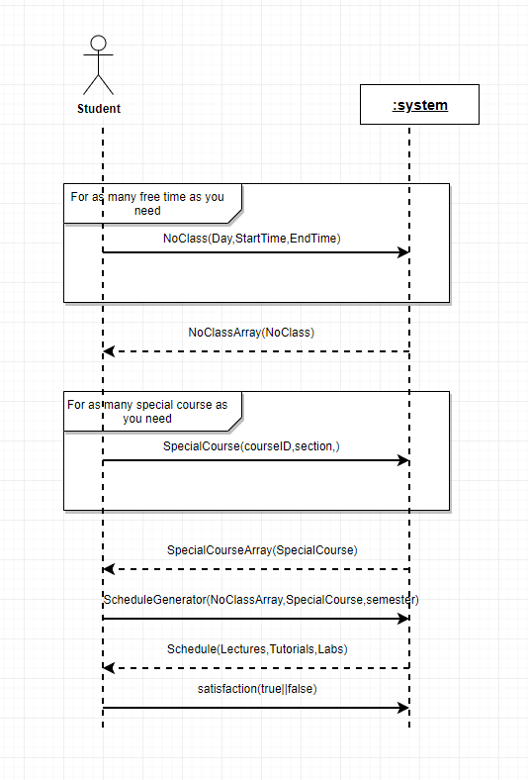

**Question 2** **Full Sequence Diagram (30 marks)**

Using the diagram of question 1, draw a full sequence diagram of the above interaction, using the objects you consider appropriate to handle all aspects of the sequence. Label both the sent message lines and the return lines.

Note that the system must have all information to ensure that there is no time conflict, the prerequisites are met and that there is space in the class.

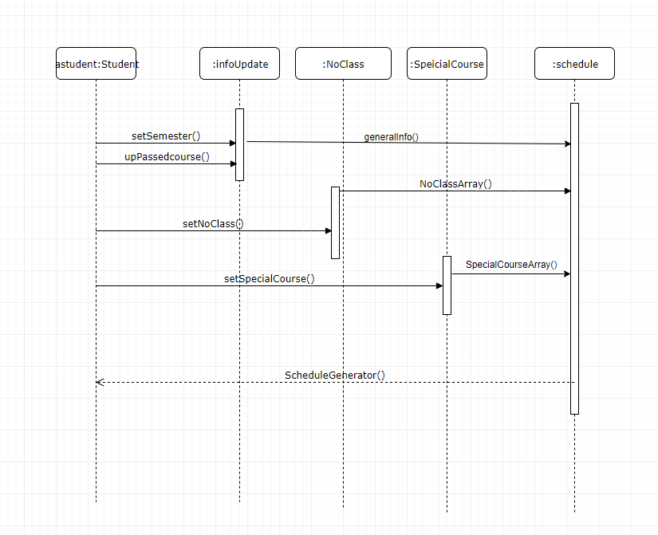

**Question 3** **Class diagram (30 marks)**

Referring to your sequence diagram of question 2, draw a class diagram showing the classes needed to model the system. Show the associations between the classes with appropriate labels, Model the classes with three sections: name, attributes and methods. Add some attributes and methods to some classes, but do not try to make fully complete entries.

Give a brief description of the diagram in a few lines of text

Give References used in this assignment.

